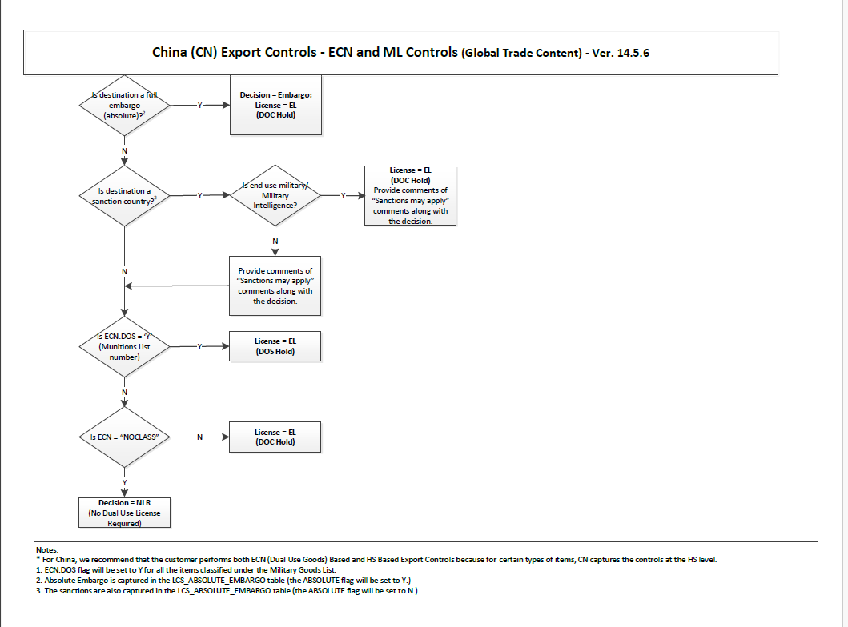
Above is the China country flow chart.
Write down a python program which will generate the agent.md file ,name it as LREQ Agent
- Read each condition mentioned in the flow chart
- For each condition, cover Y and N flow
- There are numbers mentioned in the flow chart, which are nothing but the superscripts. Refer the superscript numbers. These numbers are typically used as footnote indicators or reference markers. These are present in the Note section at the bottom of the page.
- Connect to the Content DB. Below is the DB details.

User Name: GK_GTM_OWNER
Password: GK_WORLD
Hostname: lin020
SID:GTM
Port:1521

- From the DB, Execute the below SQL query to get the list of Embargo Country(Refer the note from the Flow chart and based on that execute the SQL query. Here is the sample query to get the list of Embargo countries.

- Execute the below SQL Query to get list of Import country
Here is the sample query:
select country_id
from lcs_country_chart_global a
where a.export_country_id='GB'
and a.CB1 = 'Y'
and a.rec_status = 'A'
and a.effective_date = ( select max(b.effective_date)
from lcs_country_chart_global b
where a.export_country_id = b.export_country_id
and a.export_cntry_group = b.export_cntry_group
and a.country_id = b.country_id
and b.effective_date <= ?
)
- Execute the below SQL Query to get list of ECCN number
Here is the sample query :
select A.ECCNUM,A.CONTROL_ATTRIBUTE16,A.CB1,A.RS2
from lcs_ECCN_chart_global a
where a.export_country_id='GB'
and CB1='Y' and RS2 IS NULL and REC_STATUS='A'
and a.rec_status = 'A'
and a.effective_date = ( select max(b.effective_date)
from lcs_ECCN_chart_global b
where a.export_country_id = b.export_country_id
and a.export_cntry_group = b.export_cntry_group
and a.ECCNUM = b.ECCNUM
and b.effective_date <= SYSDATE
);
- Here is a sample file attached for France country. Analyze the file.
Location: C:\Users\pallishree.singh\OneDrive - WiseTech Global\Pallishree_Backup\D-Drive_Backup_Final\EXPORT_TRADE\26.2\Sprint3\FR

- Create a similar file for China country. inside LREQ_AUTOMATION_AI folder in C:\Users\pallishree.singh\OneDrive - WiseTech Global\Pallishree_Backup\D-Drive_Backup_Final\EXPORT_TRADE\26.2\Sprint3\CN_LREQ
-In the Input sheet, LREQ Column, replace FR with CN. Get the AGENCY Code from followed by the Agency code for China
EX: from FR_MOD_ECN to CN_<<AGENCY_CODE>>_ECN
-Replace the values under LREQ Ctry and Export Ctry as CN
-Import country get the result from Step 6 and fill Import Ctry column.
-Get the result from step7 and put under ECN column
- Follow the flow chart, take the combination of Export Ctry,Import Ctry and ECN column and arrive the decision and put the Decision under Expected Results-Decision column
-Make sure there should not be any duplicate rows created for LREQ,Export Ctry,Import Ctry and ECN combination.
10. Retain all other sheets like PARTNER,GPM and Transaction as it is.

